Gradient Descent Deep Dive
Mathematics, Variants, and Visual Intuitions
Comprehensive overview of gradient descent techniques, formulas, and practical considerations.
Autor: Maru
February 2026

Introduction to Gradient Descent
Gradient descent is an optimization process that iteratively updates model parameters to minimize a cost function. Each iteration moves the parameters in the opposite direction of the gradient, like walking downhill on a cost surface. This method is fundamental in training linear models, neural networks, and other parametric learners.The trajectory illustrated below shows how successive updates converge toward the minimum of a convex cost surface when the learning rate is set appropriately.
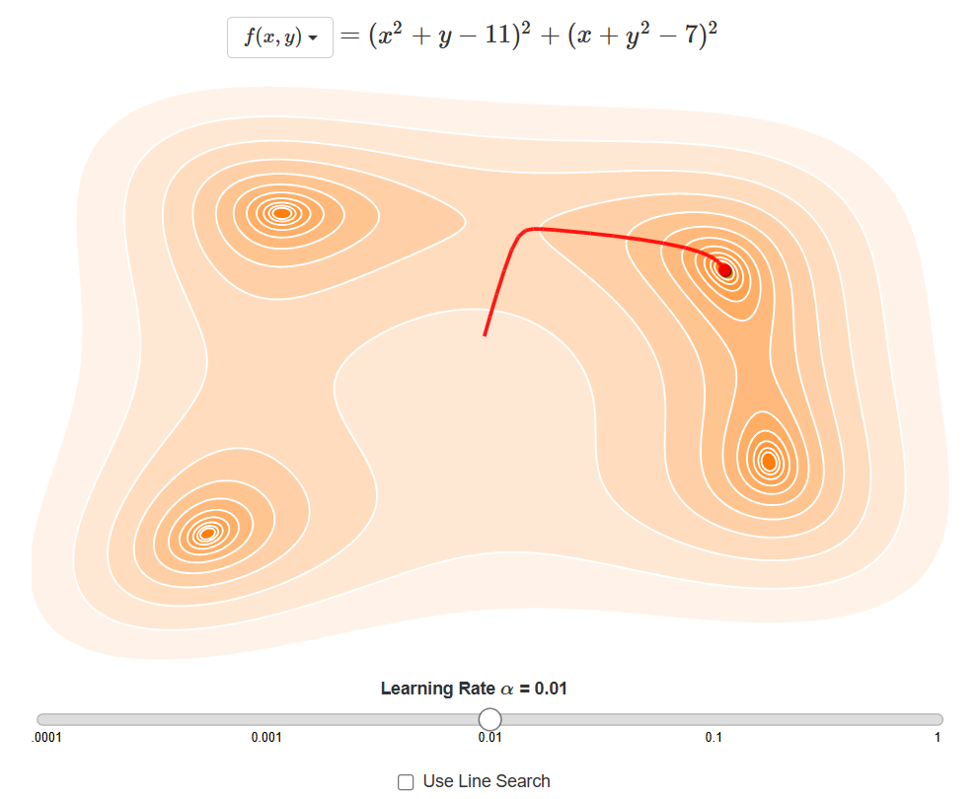
Gradient descent path for a simple convex cost surface.

Mathematical Foundations
At the heart of gradient descent lies the cost function \(J(\theta)\), which quantifies prediction error. The gradient \(\nabla_\theta J(\theta)\) collects the partial derivatives with respect to each parameter and points toward steepest ascent, so stepping in the negative gradient direction lowers the cost.
$θ←θ−α∇_{θ}J(θ)$
Standard gradient descent update with learning rate \(\alpha\).
For linear regression, \(J(\theta)=\frac{1}{2m}\sum_{i=1}^m (h_\theta(x^{(i)})-y^{(i)})^2\), and differentiating reveals how each parameter influences the squared error.
$∇_{θ}J(θ)=\left[\begin{matrix}\frac{∂J}{∂θ_{0}} \\ \frac{∂J}{∂θ_{1}} \\ ⋮\end{matrix}\right]$
Gradient vector of the cost function gathers all partial derivatives.

Variants of Gradient Descent
Depending on how much data is used for each gradient estimation, gradient descent manifests as batch, stochastic, or mini-batch, each trading off noise, stability, and computation.
- Batch gradient descent uses the entire dataset for each update, ensuring smooth progress but requiring more memory and compute per step.
- Stochastic gradient descent updates after every single example, introducing noise that can escape shallow traps but making the trajectory jittery.
- Mini-batch gradient descent processes small subsets (e.g., 32–256 examples) to balance stability with GPU-friendly vectorization.
Comparison of gradient descent variants.
Variant | Gradient Estimation | Pros | Typical Use
Batch | Full dataset per update | Stable convergence | When data fits in memory
Stochastic | Single example | Fast updates; escapes thin local minima | Online learning or streaming data
Mini-batch | Small subset (32–256) | Compromise between speed and smoothness | Most deep learning training loops
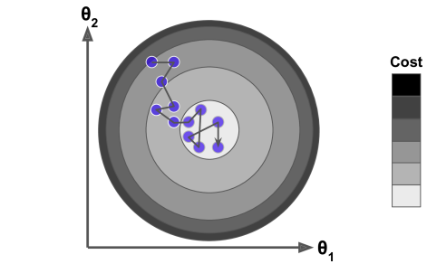
Trajectory comparison for batch, mini-batch, and stochastic gradient descent.

Geometric and Contour Insights
Contour plots in the \(\theta_1–\theta_2\) plane help visualize why the gradient is the fastest way down: it is orthogonal to level curves and points directly toward the nearest basin of attraction.
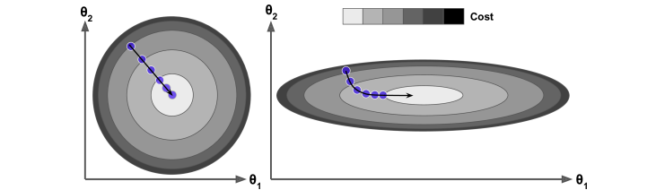
Contour map of a two-parameter cost surface with successive gradient steps.
The geometric viewpoint highlights that the gradient vector (shown below) is perpendicular to the contour lines, so the negative gradient gives the steepest descent path at any location.
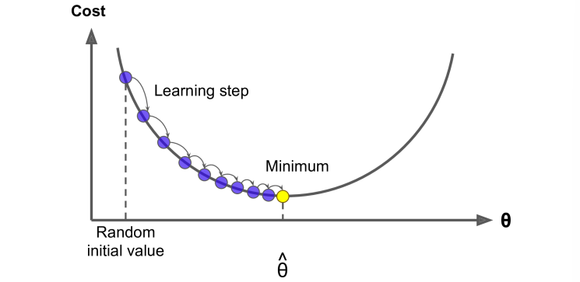
Geometric interpretation of the gradient direction in parameter space.

Practical Considerations and Pitfalls
In practice, gradient descent can slow near plateaus, bounce in narrow valleys, or get trapped around local minima, so learning rate schedules, momentum, and adaptive optimizers help navigate these challenges.
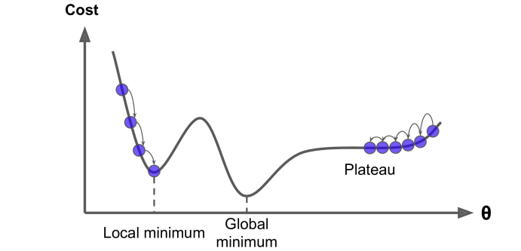
Examples of local minima, global minima, and plateaus that can mislead naive descent.
Choosing the learning rate carefully is crucial: too large causes overshooting and divergence, while too small makes convergence painfully slow as steps barely move the parameters.
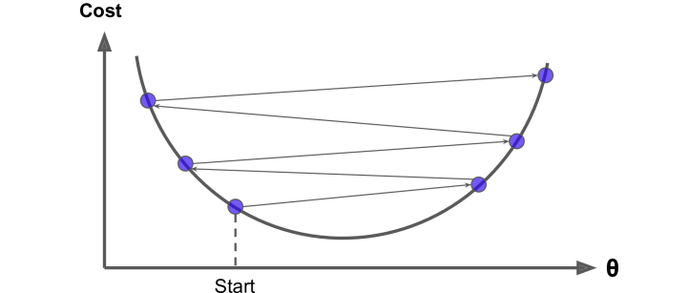
Overshooting illustrated when the learning rate is too large.
Combining the appropriate variant, tuned learning rate, geometric intuition, and modern enhancements such as momentum or Adam keeps gradient descent reliable for most optimization tasks.

